COMPREHENSIVE DIGITAL MARKETING FOR MOTHER DAIRY

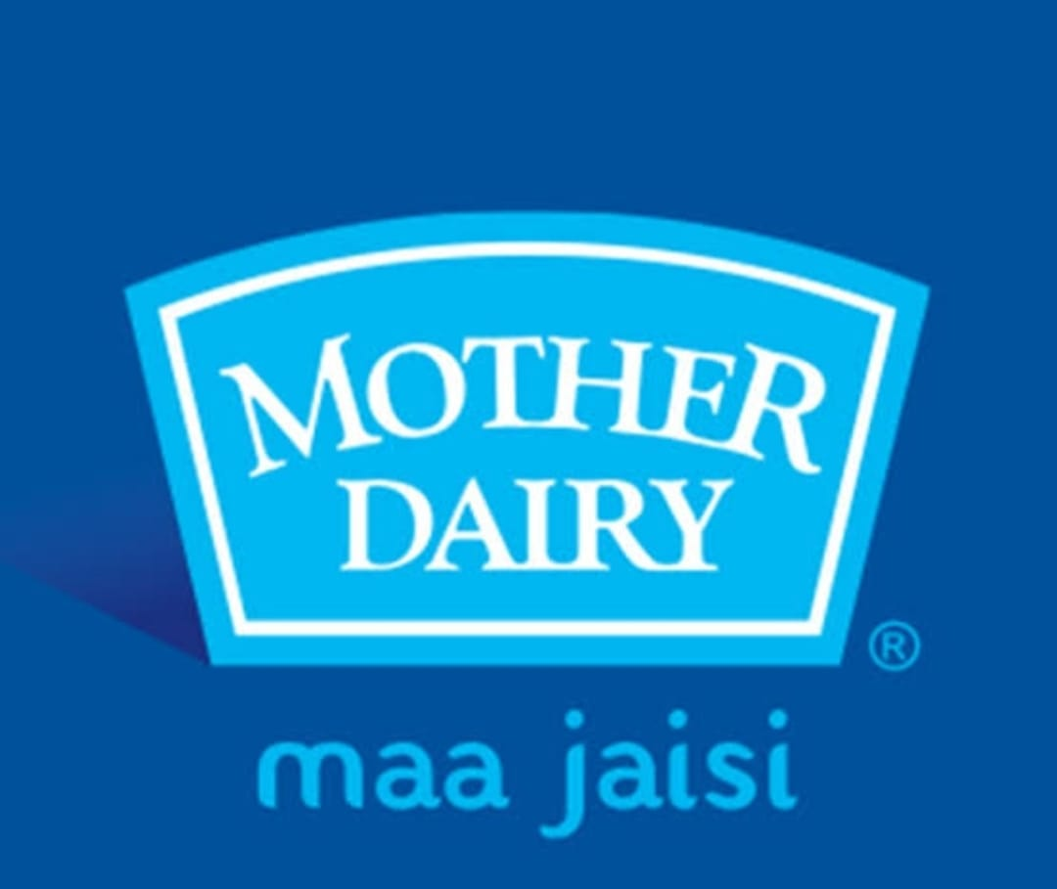

**Name:** Ale Thanuja

**College**: Vasavi mahila kalasala

**Team id**: LTVIP2025TMID21877

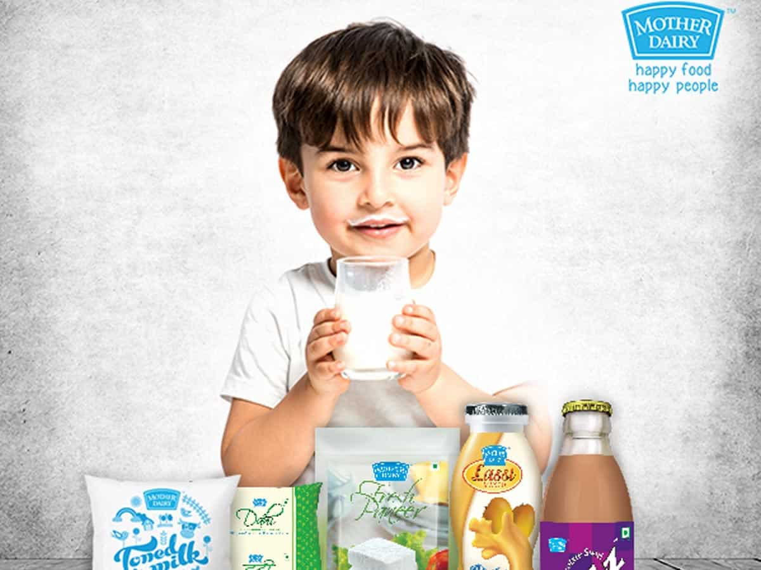

Mother Dairy, a prominent Indian dairy brand, faces competition from established players like Amul and newer entrants. Their target audience includes households, especially those in urban and semi-urban areas, seeking quality and affordable dairy products and fruits and vegetables.

* **Brand Comparison:**
* **Mother Dairy vs. Amul:**
* **Market Share**: While Amul is a dominant player, Mother Dairy holds a significant share, particularly in Delhi NCR.
* **Product Range**: Both companies offer a wide variety of dairy products, including milk, yogurt, cheese, ice cream, and ghee.
* **Marketing**: Both brands utilize various marketing channels, including advertising and promotions, to reach consumers.



* **Mother Dairy vs. Other Dairy Brands**:
* **Nandini:** A newer entrant in the Delhi market, Nandini, from Karnataka, is expected to challenge the established brands.
* **Regional Brands**: Other regional dairy brands also compete for market share, particularly in their respective regions.
* **Buyer Profile:**
* **Demographics:**

Mother Dairy’s target audience includes households in urban and semi-urban areas, with a focus on families and individuals who value quality and affordability.

* **Purchasing Behavior:**
* **Regular Dairy Consumers**: A large percentage of consumers regularly purchase dairy products, with milk, curd, and ice cream being popular choices.
* **Brand Loyalty**: Many consumers are loyal to Mother Dairy, recognizing the brand and its products.
* **Price Sensitivity**: While quality is important, consumers are also price-conscious, seeking value for their money.
* **Other Factors:**
* **Convenience:** Consumers appreciate the availability of Mother Dairy products through various retail outlets and exclusive stores.
* **Trust and Reliability**: Mother Dairy’s strong brand image and reputation for quality play a significant role in consumer decisions.
* **Safal (F&V arm):** Mother Dairy’s Safal arm caters to the organized fruit and vegetable retail business, targeting consumers seeking fresh produce.

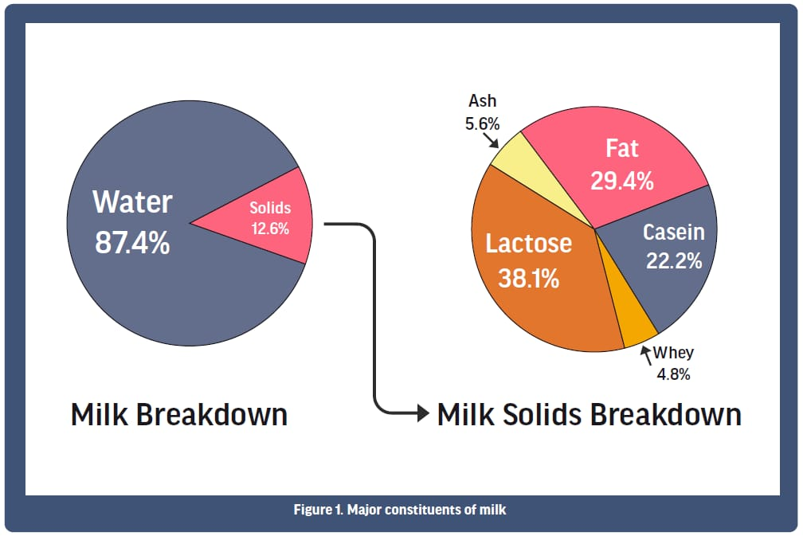

* **Brand study competitor analysis and buyers/audience persona**:
* **History and Operations**:

Mother Dairy, established under Operation Flood, produces and distributes milk, dairy products, edible oils, fresh produce, and processed foods, sourcing milk from dairy cooperatives and village organizations.

* **Product Range:**

Mother Dairy offers a diverse product portfolio, including milk (different variants), flavoured yogurt, ice cream, and traditional Indian sweets, with a focus on quality and innovation.

* **Marketing Strategies**

Mother Dairy employs strategies like product differentiation, quality control, social campaigns, and mascots to promote its brands, including Safal and Dhara.

* **Market Presence:**

While initially focused on Delhi, Mother Dairy has expanded across India and exports products to over 40 countries, aiming to diversify its product range and expand market share.

* **Competitor Analysis:**
* **Key Competitors:**

The main competitors are Amul (a leading Indian food and drinks brand) and Nandini, with Amul holding a significant market share.

* **Competitive Landscape:**

The dairy market is competitive, with companies vying for market share through product innovation, quality, and distribution strategies.

* **Competitive Advantages:**

Amul has high brand awareness, while Mother Dairy focuses on quality and affordability, and Nandini is known for its focus on fresh milk.

* **Market Share:**

Amul accounts for about 40-45% of the market share, while Mother Dairy holds a 35-38% market share.

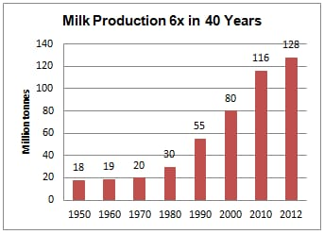

* **Buyer Audience Persona:**
* **Demographics**:

The target audience includes people of all ages and genders, with a focus on families and health-conscious individuals.

* **Psychographics:**

Consumers are often health-conscious, seeking products that align with their dietary goals, and value quality and affordability.

* **Needs and Preferences:**

Consumers seek a variety of dairy products, including milk, yogurt, and ice cream, and value freshness, quality, and convenience.

* **Purchase Behavior:**

Consumers regularly purchase dairy products, with a preference for brands they trust and recognize.

* **Example Persona:**

“A busy working mother in her late 30s, concerned about her family’s health and nutrition, who prioritizes quality and affordability when purchasing dairy products”.

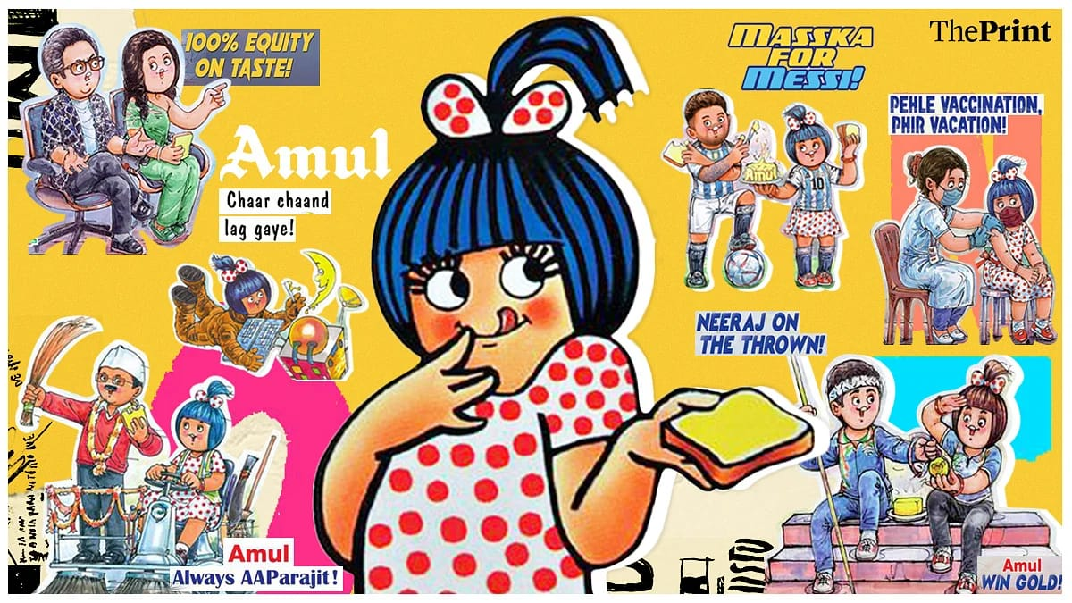

* **seo and key research:**

Analyze the content and backlinks of competitor websites to identify opportunities for improvement.

5. **Tools and Resources:**

* **SEO Tools:**

Utilize SEO tools like Google Analytics, Google Search Console, SEMrush, Ahrefs, and Moz to track website performance and identify areas for improvement.

* **Local SEO Tools:**

Use tools like Google My Business, Yelp, and other local listing platforms to optimize for local search.

6. **Research and Analysis:**

* **Customer Feedback**: Analyze customer reviews and feedback to identify areas for improvement.
* **Market Trends**: Stay up-to-date on the latest trends in the dairy industry and adjust SEO strategies accordingly.
* **Data Analysis**: Regularly analyze website data to track SEO performance and identify areas f Content Ideas:

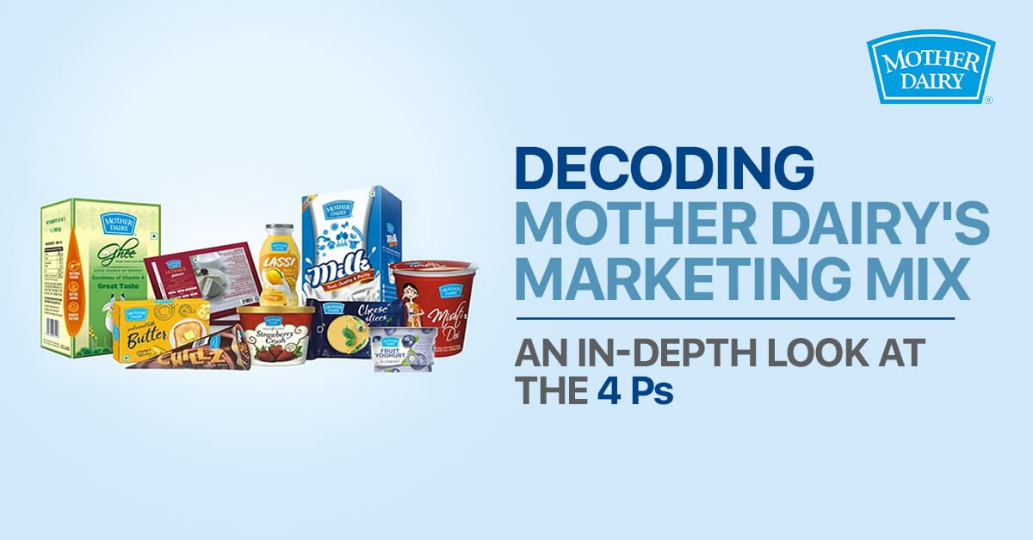

* **Highlighting Product Quality and Benefits:**
* **“From Farm to Fridge” Series**: Showcase the journey of Mother Dairy products, from the farm to the consumer, emphasizing the quality and freshness.
* **Nutritional Information**: Create informative content about the health benefits of different dairy products, targeting specific demographics (e.g., calcium for kids, protein for athletes).
* **Recipe Ideas**: Share easy and healthy recipes featuring Mother Dairy products, encouraging culinary creativity.
* **“Meet the Farmer” Stories**: Introduce the farmers who supply Mother Dairy, building trust and highlighting their dedication.
* **Building Emotional Connection**:
* **Family-Focused Content**: Create content that emphasizes the role of dairy in family meals and healthy lifestyles.
* **“Mom’s Choice” Content**: Focus on the importance of dairy in a child’s diet and how Mother Dairy products support healthy growth.
* **Community Events**: Organize events like cooking workshops, health checkups, or farmer meetups to connect with the community.
* **Sustainability and CSR:**
* **Highlight Sustainable Practices**: Share information about Mother Dairy’s efforts to reduce carbon footprint and water usage.
* **CSR Initiatives**: Promote their activities that support dairy farmers and community welfare.

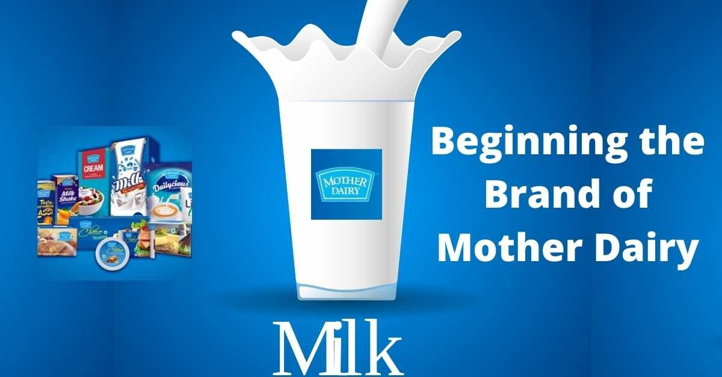

* **Digital Marketing:**
* **Social Media Campaigns**: Run interactive campaigns, polls, and contests to engage with followers.
* **Influencer Marketing**: Partner with relevant influencers to promote Mother Dairy products.
* **Email Marketing:** Send out newsletters with product updates, recipes, and special offers.
* **Targeted Advertising:** Use online advertising to reach specific demographics and interests or improvement.



* **contact creation and curation:**

The Indian ice cream brand used social listening tool Social CRM 24x7 to analyse moments their consumers were interested in talking about or reading. Based on the results, they made pieces of creative in real-time that fit the context.

According to WATConsult, the agency behind the campaign, the project resulted in a 42% increase in organic engagement across one year, and a 78% change in brand sentiment.

The Drum spoke with Randhir Kumar, general manager of marketing for Dairy Products at Mother Dairy Fruit and Vegetable about the campaigns.

How will this inform future marketing?

There will always be a trending topic doing the rounds on social media or news. With a never ending path of trends, we shall look at widening the strategy of leveraging the trends or the chatter of certain topical moments and fit in our products accordingly, which shall help us to put the brand in focus again and again in a larger way.

The Indian ice cream brand used social listening tool Social CRM 24x7 to analyse moments their consumers were interested in talking about or reading. Based on the results, they made pieces of creative in real-time that fit the context.

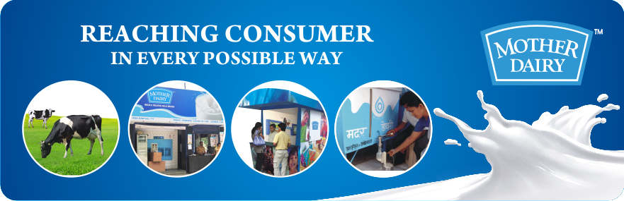

According to WATConsult, the agency behind the campaign, the project resulted in a 42% increase in organic engagement across one year, and a 78% change in brand sentiment.

The Drum spoke with Randhir Kumar, general manager of marketing for Dairy Products at Mother Dairy Fruit and Vegetable about the campaign

Community Events:

Organize online and offline events to engage with customers and build brand loyalty.

Participate in local festivals and events to increase brand visibility.

Loyalty Programs:

Develop a loyalty program to reward repeat customers and encourage engagement.

Offer exclusive discounts and promotions to loyal customers.

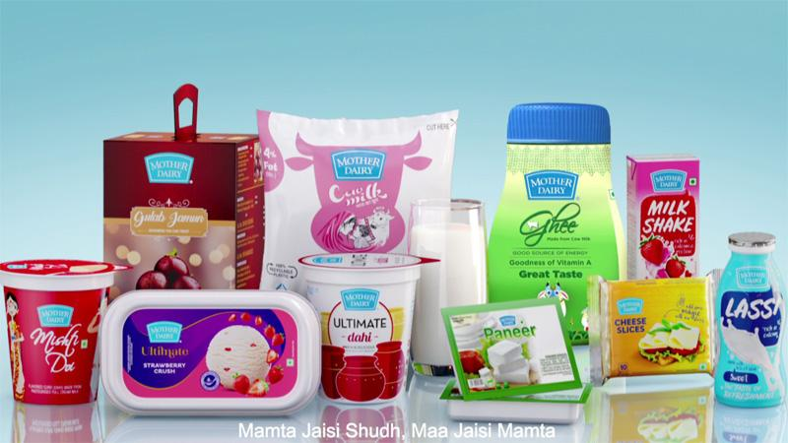

3**. Targeted Advertising:**

Search Engine Marketing (SEM):

Use targeted keywords and ad campaigns to reach potential customers searching for dairy products and related terms.

Monitor ad performance and optimize campaigns for better results.

**Social Media Advertising:**

Target specific demographics and interests on social media platforms.

Run targeted ad campaigns to promote specific products and promotions.

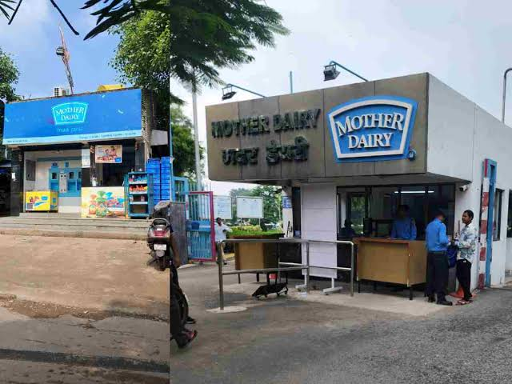

**Email Marketing:**

Build an email list and send out regular newsletters with product updates, promotions, and recipes.

Personalize email campaigns based on customer preferences and purchase history.

4**. Data Analytics & Reporting:**

**Track Key Metrics:**

Monitor website traffic, social media engagement, ad performance, and sales data to assess the effectiveness of digital marketing efforts.

**Analyze Data:**

Use data analytics tools to identify trends, patterns, and areas for improvement.

Report on Results:

Regularly report on digital marketing performance to stakeholders and make data-driven decisions.

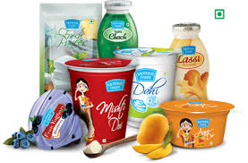

5. **Specific to Mother Dairy:**

**Highlight Cooperative Model**:

Emphasize Mother Dairy's cooperative business model and its commitment to supporting local dairy farmers.

**Focus on Quality & Freshness:**

Promote the quality and freshness of Mother Dairy products, emphasizing their nutritional benefits.

**Leverage "Maa Jaisi" (Like Mother's) Campaign:**

Continue to build on the "Maa Jaisi" campaign by showcasing the brand's connection to family and tradition.

**Consider Local Language Content:**

Create content in regional languages to reach a wider audience in different parts of India.

As the largest milk brand in Asia, Mother Dairy commands over 40% of India’s dairy needs. The company’s revenue in 2020 stood at over ₹10,000 crore rupees (approximately $1.6 billion), highlighting its significant presence in the market. Additionally, Mother Dairy’s retail arm, Safal, exports fresh fruits, vegetables, fruit pulp, and concentrates to 40 countries, showcasing its global outreach

The cooperative model adopted by Mother Dairy ensures a steady supply of fresh milk by sourcing a significant portion of its liquid milk from dairy cooperatives and farmer-centric organizations. This not only supports over 8 crore farmers directly but also

contributes to nearly 5% of India’s GDP through the dairy sector.

**Key Takeaways:**

Mother Dairy is a trusted brand that offers a wide range of dairy products, fruits and vegetables, edible oils, and processed foods.

The company focuses on providing fresh, nutritious, and safe products to middle-class and upper-middle-class families.

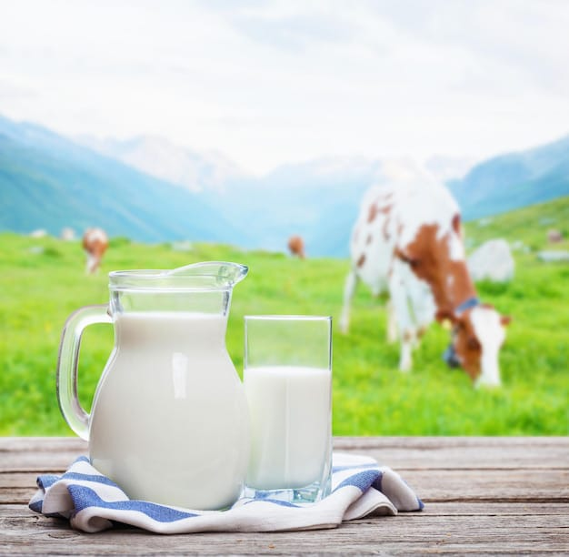

Mother Dairy has gained the trust and loyalty of millions of customers across India.

Under its Dhara sub-brand, Mother Dairy offers various types of edible oils, while its Safal sub-brand specializes in providing fresh fruits and vegetables.

Mother Dairy implements strategic pricing, adapting to fluctuations in raw material costs to offer competitive prices.

* The main reasons for the low yield are: ·
* Lack of use of scientific practices in mulching.
* Inadequate availability of fodder in all seasons.
* Unavailability of veterinary health services.
* Indian Dairy Products
* The term Indian Dairy Products refers to those milk products, which originated in undivided India.
* Major Players
* There are virtually 15 major Dairy Cooperative Federations in India, namely:
* Andhra Pradesh Dairy Development Cooperative Federation Ltd (APDDCF)
* Bihar State Cooperative Milk Producers’ Federation Ltd (COMPFED)
* Gujarat Cooperative Milk Marketing Federation Ltd (GCMMF)
* Haryana Dairy Development Cooperative Federation Ltd. (HDDCF)
* Himachal Pradesh State Cooperative Milk Producers’ Federation Ltd (HPSCMPF)

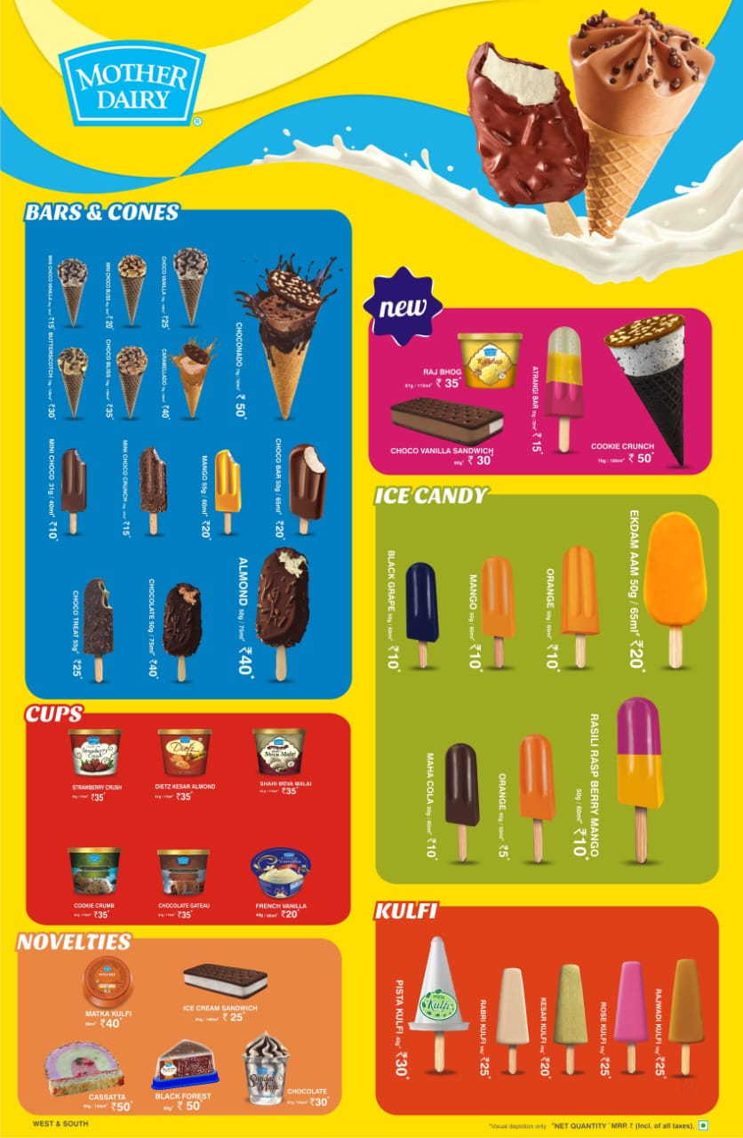

* Few common strategies adopted by them is as follows:
* Common branding
* Focused approach
* Product differentiation
* Smart Marketing
* Product enhancement and assured quality etc